**Assignment-2: Accessing HDFS through Java program**

**Chaitanya Sai Nutakki  
AP21110010253**

1. **WRITE OPERATION:**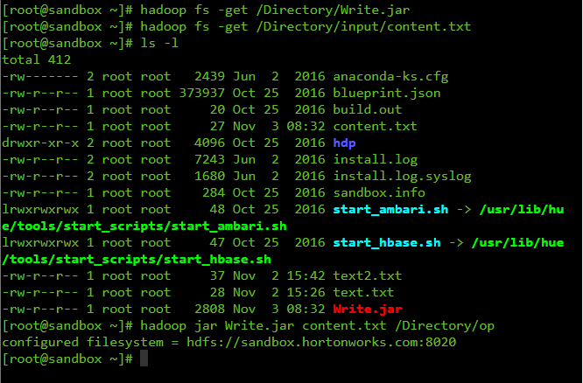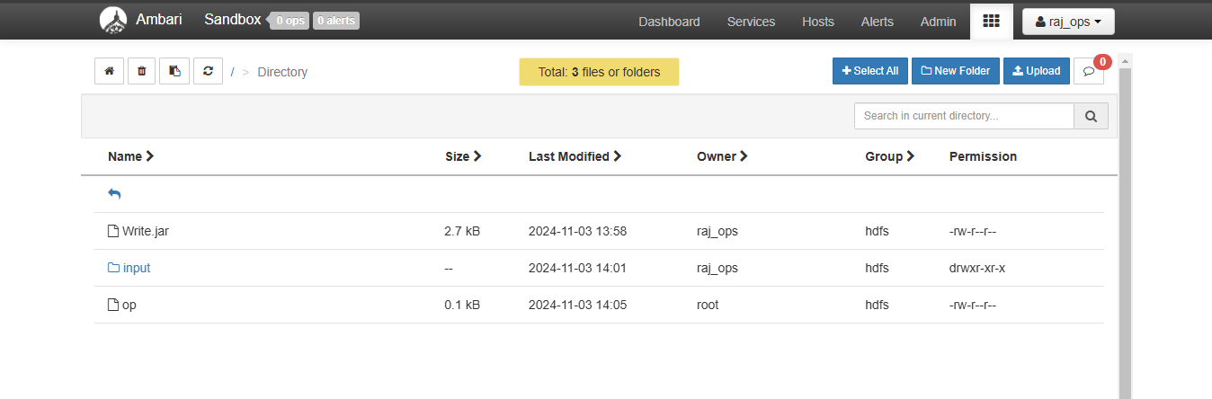

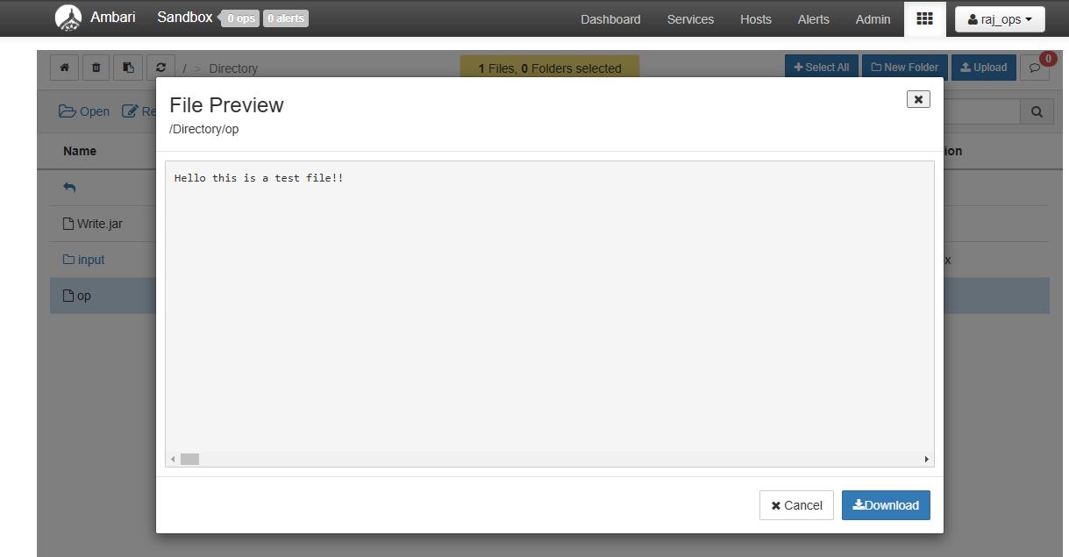

1. **READ OPERATION:**